Data Analysis Solution
Solution of Problem 1
- The light curve (10 points)
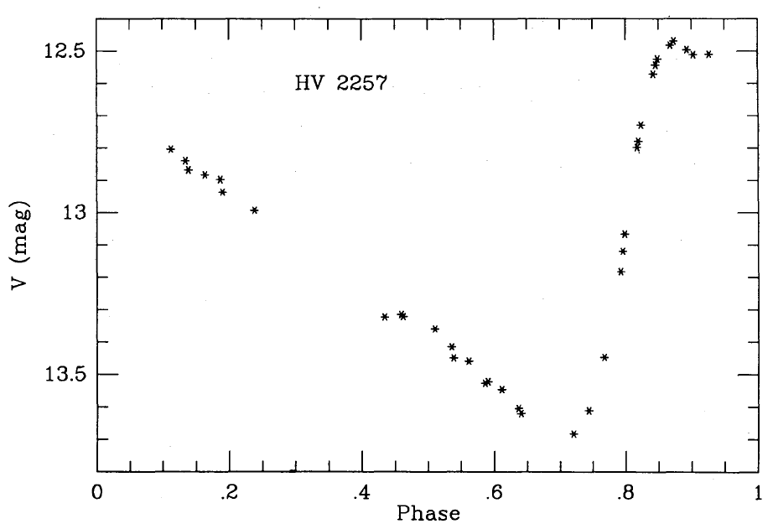
Gieren 1993 (MNRAS vol 265)

- The color curve (10 points)
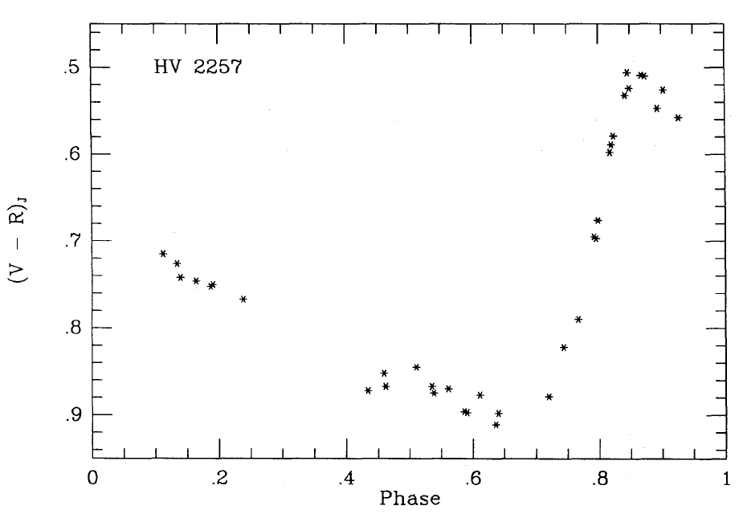
Gieren 1993 (MNRAS vol 265)

- The radial velocity curve (10 points)
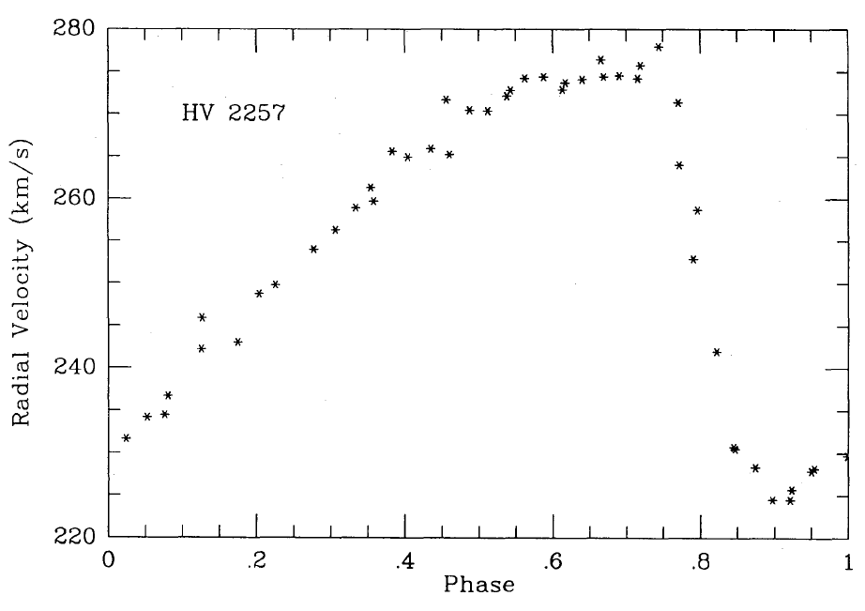
Gieren 1993 (MNRAS vol 265)

Solar absolute bolometric magnitude calculation (5 points)
F is the solar flux at the distance 10 pc which corresponds to the solar bolomatric absolute magnitude.
$$F_{⨀}=\frac{L_{⊙}}{4π⋅{\left(10pc\right)}^{2}}=\frac{3.96⋅{10}^{26}}{4⋅3.14⋅100⋅{3.086}^{2}⋅{10}^{32}}=3.31⋅{10}^{-10}W/m^{2}$$

Formula derivation (15 points)
From Stefan–Boltzmann equation we have luminosity of star:
$L=4πR^{2}σT^{4}$,
here $R$ is radius of the star, $σ$ is the Stefan–Boltzmann constant, and $T$ is effective temperature of star. Star flux at distance $d$ will be equal:
$$F=\frac{σR^{2}T^{4}}{d^{2}}$$
From Pogson definition we have:
$$m_{1}-m_{2}=-2.5log\frac{F_{1}}{F_{2}}$$
Or using the Sun as reference, a star’s observed bolometric flux will be:
$$F=F_{⨀}{10}^{-\frac{m_{bol}-M_{⊙bol}}{2.5}}$$
Consider two moments, say t₁ and t₂. It is better to choose the phase t₁ and t₂ during which the star’s expansion acceleration close to constant, and the difference in magnitude and color as large as possible. At the moment $t_{1}$, with measured temperature $T_{1}$ and radius $R_{1}$ , absolute bolometric flux will be:
$$F_{1}=\frac{σR_{1}^{2}T_{1}^{4}}{d^{2}}$$
…………………………………………………………….. (1a)
Later, at moment $t_{2}$ :
$$F_{2}=\frac{σR_{2}^{2}T_{2}^{4}}{d^{2}}$$
…………………………………………………………….. (1b)
During this time, the star’s atmosphere has expanded from R₁ to R₂ :

$$R_{2}=R_{1}+ΔR$$
or:
$$\frac{R_{2}}{R_{1}}=1+\frac{∆R}{R_{1}}$$
Reminding :
$$\frac{F_{2}}{F_{1}}={\left(\frac{T_{2}}{T_{1}}\right)}^{4}{\left(\frac{R_{2}}{R_{1}}\right)}^{2}$$
We have
$$\frac{F_{2}}{F_{1}}={\left(\frac{T_{2}}{T_{1}}\right)}^{4}{\left(\frac{∆R}{R_{1}}+1\right)}^{2}$$
……………………………………………………………………. (2)
From Pogson definition, and (2) we can find:
$$R_{1}=\frac{∆R}{{\left(\frac{T_{1}}{T_{2}}\right)}^{2}∙{10}^{-\frac{m_{2}-m_{1}}{5}}-1}$$

Calculation of ΔR from the radial velocity graph (20 points)
For finding ΔR, we can use radial velocity curve, taking two moments, t₁ and t₂, between which the expansion acceleration can be assumed constant,
$$ΔR=(v_{2}-v_{1})\frac{ΔφP}{2}$$
here $P$ is pulsation period of star and $Δφ$ is phase difference in moment between $t_{1}$ and $t_{2}$.
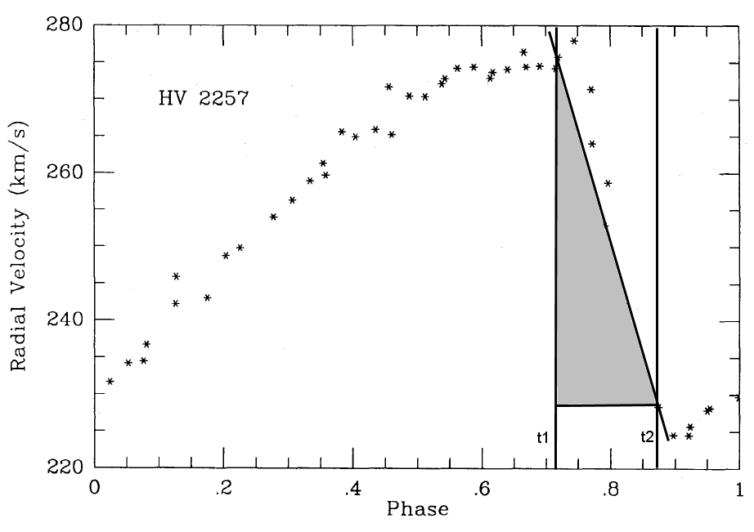
--------------------------------------
Alternative method using integral / sum :
$$ΔR=\int_{t_{1}}^{t_{2}}{v\left(t\right)dt}$$
We can calculate the integral by drawing lines connecting two adjacent points, calculating the area of the trapesium under the line segment and sum up for all line segment between moment $t_{1}$ and $t_{2}$
--------------------------------------
So, from radial velocity curve we choose the part of the graph which is close to linear :
$t_{1}=0.7$5
$$t_{2}=0.85$$
Which corresponds to $v\left(t_{1}\right)=$272 km/s
$v\left(t_{2}\right)=230$ km/s
Now we can calculate$ΔR$:
$$ΔR=\frac{\left(230000-272000\right)\left(0.85-0.75\right)⋅39.294⋅86400}{2}=-7.13⋅{10}^{9}m$$

Temperatures and magnitudes from photometric data (10 points)
For moments $t_{1}$ and $t_{2 }$:
From light curve we have the magnitude V:
$$V_{1}=13.58$$
$$V_{2}=12.55$$
From color curve we have the color V-R
$${(V-R)}_{1}=0.81$$
$${(V-R)}_{2}=0.53$$
From Fig. 1 we can find the temperatures:
$T_{1}=$4000K
$T_{2}=$4750K
From table 4 we have bolometric corrections for these moments (by using Table 4 with linear interpolation):
$${BC}_{1}=-1.23$$
$${BC}_{2}=-0.52$$
Now we can calculate bolometric magnitudes:
$$m_{bol}\left(t_{1}\right)=13.58-1.23=12.35$$
$$m_{bol}\left(t_{2}\right)=12.55-0.52=12.03$$

Calculate $R_{1}$ (10 points):
First we calculate star’s observed flux:
$$F_{1}=2.913⋅{10}^{-10}⋅{10}^{-\frac{12.35-4.72}{2.5}}=2.584⋅{10}^{-13}W/m^{2}$$
Then the radius of the star at the moment t₁ will be :
$$R_{1}=\frac{∆R}{{\left(\frac{T_{1}}{T_{2}}\right)}^{2}∙{10}^{-\frac{m_{2}-m_{1}}{5}}-1}=\frac{-7.13⋅{10}^{9}}{{\left(\frac{4000}{4750}\right)}^{2}∙{10}^{-\frac{12.03-12.35}{5}}-1}=4.0⋅{10}^{10}m$$

Calculate distance (10 points)
$$d=\sqrt{\frac{σ⋅R_{1}^{2}⋅T_{1}^{4}}{F_{1}}}=3.0⋅{10}^{20}m=\frac{3.0⋅{10}^{20}}{3.086⋅{10}^{16}}=9.72 kpc$$
Answer: 9.72 kpc

Solution of Problem 2

- Using the data from tables 5 to 9 and recalling that MK class II corresponds to giant stars while MK classes Ia and Iab correspond to supergiants, we easily obtain tables 10 to 12 and hence figures containing the plots of $E_{X-V}/E_{B-V}$ against $1/λ_{X}$ for both stars.

Table 10 (10 points)
Star | $$\frac{B-V}{mag}$$ | $$\frac{V-V}{mag}$$ | $$\frac{R-V}{mag}$$ | $$\frac{I-V}{mag}$$ | $$\frac{J-V}{mag}$$ | $$\frac{H-V}{mag}$$ | $$\frac{K-V}{mag}$$ | $$\frac{L-V}{mag}$$ | $$\frac{M-V}{mag}$$ | $$\frac{N-V}{mag}$$
HD 4817 | 1.9 | 0 | -1.45 | -2.54 | -3.42 | -4.32 | -4.64 | -4.86 | -4.59 | -
HD 11092 | 2.09 | 0 | - | - | -3.47 | -4.43 | -4.94 | -5.16 | -4.92 | -5.13

Table 11 (10 points)
Star | $$\frac{{\left(B-V\right)}_{0}}{mag}$$ | $$\frac{{\left(V-V\right)}_{0}}{mag}$$ | $$\frac{{\left(R-V\right)}_{0}}{mag}$$ | $$\frac{{\left(I-V\right)}_{0}}{mag}$$ | $$\frac{{\left(J-V\right)}_{0}}{mag}$$ | $$\frac{{\left(H-V\right)}_{0}}{mag}$$ | $$\frac{{\left(K-V\right)}_{0}}{mag}$$ | $$\frac{{\left(L-V\right)}_{0}}{mag}$$ | $$\frac{{\left(M-V\right)}_{0}}{mag}$$ | $$\frac{{\left(N-V\right)}_{0}}{mag}$$
HD 4817 | 1.42 | 0 | -1.13 | -1.96 | -2.41 | -3.14 | -3.25 | -3.39 | -3.25 | -3.63
HD 11092 | 1.42 | 0 | -0.96 | -1.61 | -2.16 | -2.77 | -3.05 | -3.22 | -3.08 | -3.02

Table 12 (10 points)
Star | $$\frac{E_{B-V}}{E_{B-V}}$$ | $$\frac{E_{V-V}}{E_{B-V}}$$ | $$\frac{E_{R-V}}{E_{B-V}}$$ | $$\frac{E_{I-V}}{E_{B-V}}$$ | $$\frac{E_{J-V}}{E_{B-V}}$$ | $$\frac{E_{H-V}}{E_{B-V}}$$ | $$\frac{E_{K-V}}{E_{B-V}}$$ | $$\frac{E_{L-V}}{E_{B-V}}$$ | $$\frac{E_{M-V}}{E_{B-V}}$$ | $$\frac{E_{N-V}}{E_{B-V}}$$
HD 4817 | 1.00 | 0.00 | -0.67 | -1.21 | -2.10 | -2.46 | -2.90 | -3.06 | -2.79 | -
HD 11092 | 1.00 | 0.00 | - | - | -1.96 | -2.48 | -2.82 | -2.90 | -2.75 | -3.15

(10 points)

(10 points)
- We have that $E_{λ-V}=A_{λ}-A_{V}→{-A}_{V}$ as $λ→∞$, so the plot of $E_{X-V}/E_{B-V}$ against $1/λ_{X}$ intersects the vertical axis at
$$\frac{{-A}_{V}}{E_{B-V}}=-R_{V}.$$
(10 points)

Hence $R_{V}$ can be read off as minus the intersection of the plot with vertical axis. For the two stars we get Table 13 (the intersection points are obtained by fitting a curve to guide the eye, noting that as $1/λ→0$, the curve becomes flat, as hinted at above).

Table 13 (10 points)
Star | $$R_{V}$$
HD 4817 | 3.1
HD 11092 | 3.0

Next,
$$R_{r,r-i}=\frac{A_{r}}{E_{r-i}}=\left(\frac{E_{r-V}}{E_{B-V}}+\frac{A_{V}}{E_{B-V}}\right)\frac{E_{B-V}}{E_{r-i}}=\frac{\frac{E_{r-V}}{E_{B-V}}+R_{V}}{\frac{E_{r-V}}{E_{B-V}}-\frac{E_{i-V}}{E_{B-V}}},$$

where $E_{r-V}/E_{B-V}$ and $E_{i-V}/E_{B-V}$ can be read off from the plot (again, by fitting a curve to guide the eye). Hence we get Table 14.

Table 14 (10 points)
Star | $$R_{r}$$
HD 4817 | 3.7
HD 11092 | 3.6

Hence we take the expected values to be $R_{V}≈3.1$ and $R_{r}≈3.7$. Note that the first value agrees with the widely used ratio of the total to selective extinction in filters B and V.

- First let us find the apparent distance moduli $μ_{r,i}$ in filters r and i. Reading off the fitted values e.g. at $\log\left(P/day\right)=1.6$ from figures 2 and 3 and substituting into the period-luminosity relations, we find $μ_{r}=29.0 mag$ and $μ_{i}=28.6 mag$, so $E_{r-i}=A_{r}-A_{i}=μ_{r}-μ_{i}=0.4 mag$ and so $A_{r}≈3.7E_{r-i}=1.5 mag$. Hence the unreddened distance modulus is $μ_{0}=μ_{r}-A_{r}=27.5 mag$ and so we estimate the distance to IC 342 to be $3.2 Mpc$. (20 points)

